**PIZZA SALES SQL QUERIES**

**(MS SQL)**

1. **KPI’S**
2. **Total Revenue:**

select SUM(total_price) as Total_Revenue from pizza_sales



1. **Avg order value:**

select SUM(total_price)/COUNT(distinct order_id) as Avg_order_value from pizza_sales



1. **Total pizzas sold:**

select SUM(quantity) as total_pizzas_sold from pizza_sales

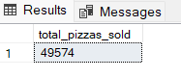

1. **Total Orders:**

select count(distinct order_id) as Total_orders from pizza_sales

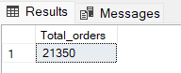

1. **Avg Pizzas per Order:**

select cast(cast(SUM(quantity) as decimal(10,2))/cast(COUNT(distinct order_id) as decimal(10,2)) as decimal(10,2)) as Avg_pizzas_per_order from pizza_sales

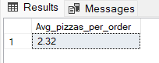

1. **DAILY TREND FOR TOTAL ORDERS**

select DATENAME(dw,order_date) as Order_day,count(distinct order_id) as Total_orders

from pizza_sales

group by DATENAME(dw,order_date)

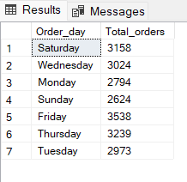

1. **HOURLY TREND FOR TOTAL ORDERS**

select DATEPART(hour,order_time) as Order_hours, count(distinct order_id) as Total_orders

from pizza_sales

group by DATEPART(hour,order_time)

order by DATEPART(hour,order_time)

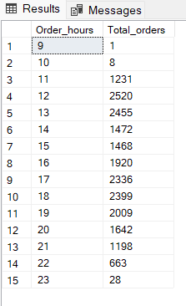

1. **% SALES BY PIZZA CATEGORY**

select pizza_category,cast(sum(total_price) as decimal(10,2)) as Total_Revenue ,

cast(sum(total_price)*100/(select sum(total_price) from pizza_sales) as decimal(10,2)) as PCT

from pizza_sales

group by pizza_category

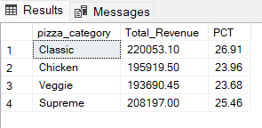

1. **% SALES BY PIZZA SIZE**

select pizza_size,cast(sum(total_price) as decimal(10,2)) as Total_Revenue ,

cast(sum(total_price)*100/(select sum(total_price) from pizza_sales) as decimal(10,2)) as PCT

from pizza_sales

group by pizza_size

order by pizza_size

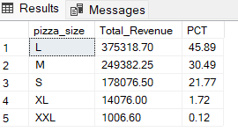

1. **Total Pizza sold by Category**

select pizza_category, sum(quantity) as Total_pizza_sold

from pizza_sales

group by pizza_category

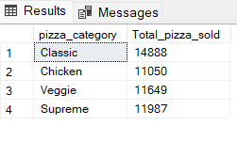

1. **TOP 5 BEST SELLERS BY TOTAAL PIZZA SOLD**

select top 5 pizza_name,sum(quantity) as Total_pizza_sold from pizza_sales

group by pizza_name

order by sum(quantity) desc

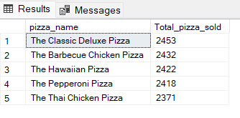

1. **BOTTOM 5 BEST SELLERS BY TOTAL PIZZA SOLD**

select top 5 pizza_name,sum(quantity) as Total_pizza_sold from pizza_sales

group by pizza_name

order by sum(quantity)

